**Final Project Report: Nail**

**Zhaoyu Yan**

1. **Project improving**  
   **a.** During my demo, I found the new user by signing up was denied by login page, while I tested it successfully yesterday. Now, I realize it’s due to response time which is faster when app and server in the same network, so when I presented the new user have not finished uploading data when login page get all users. And now, I use asynchronized task to fix it.  
   **b.** TA mentions I should add search bar to comments. Following is what I do:  
    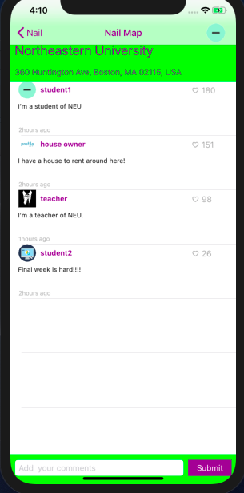   
    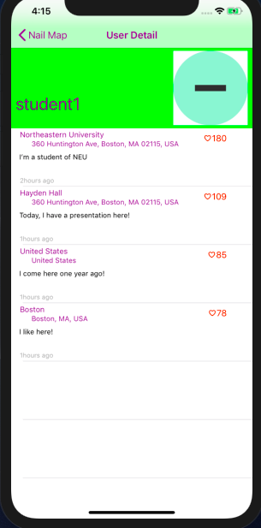 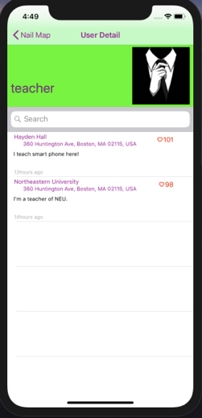
2. **Introduction**There are many social apps and many apps based on location as well, but social apps all rely on relationships among people and apps based on location are only focus on one specific aspect: food, weather or rent. I combine two kinds of apps to create my app, Nail. Nail is an app that can write comments to any place by anyone, so it’s like a social app based on map. As you see, Nail is used to share information in a place or an area.
3. **Skills or tools I used for my project  
   a.** Google Map API & Google Places API  
   **b.** Pull-up nested view controller  
   **c.** build my own server by mongoDB and node.js
4. **Go through my project with codes  
   a.** My project has two core entities: User, Comment. One sub entity: 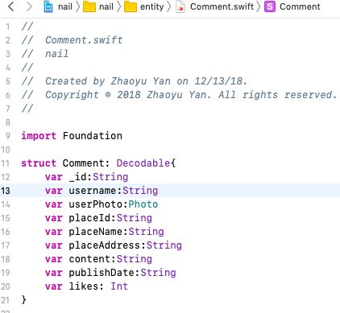Photo, is for easy to decode from json file.  
   **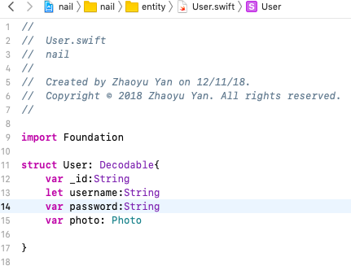  
     
     
     
     
   b.** LoginViewController is for getting all users, users log in with validation and able to guide to SignupViewController.  
   **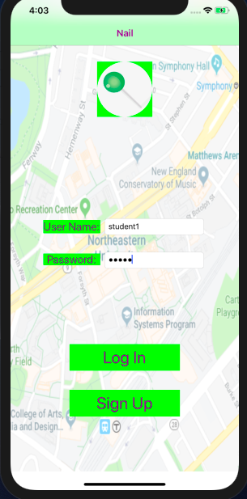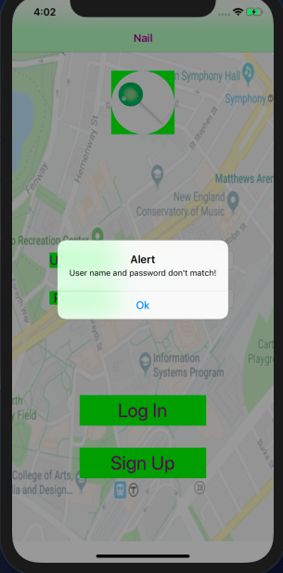  
     
      
     
     
     
     
     
   c.** SignupViewController is for create a new user and upload to server. Username should be unique, and two passwords should be same.   
   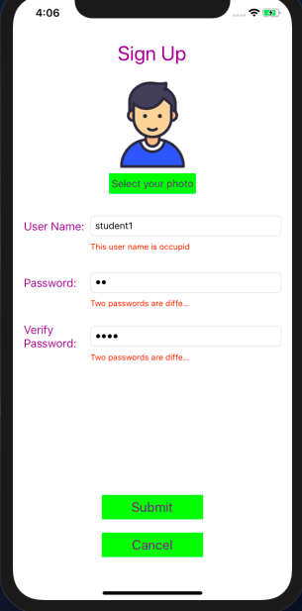   
     
   **d.** MainViewController is for presenting a google map and can search locations.   
   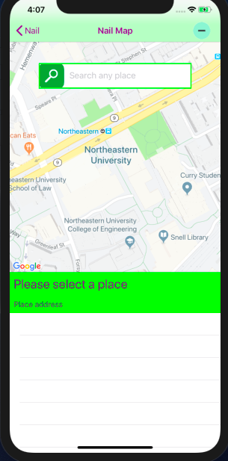   
     
   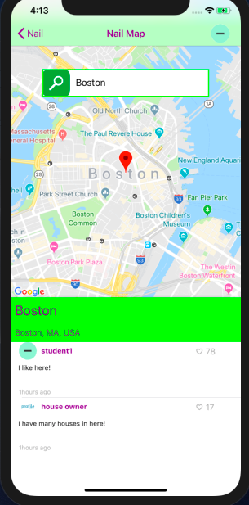   
    **e.** CommentsViewController is nested by MainViewControler. It can be pulled up or drag down to maximum or minimum it’s showing view  
   **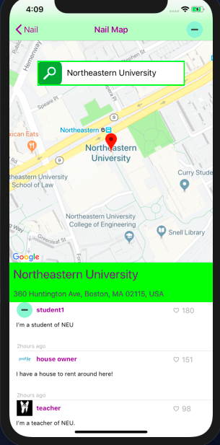  
     
     
     
     
     
     
     
     
     
     
   f.** CommentsViewController shows all comments to this place. Each comment includes user photo, user name, number of likes, content, and duration time to now.   
     
    **g.** CommentsViewController’s buttom is where the user can write ****their own comments to this place and upload it to server.  
     
    **h.** When click user photo on the MainViewController’s navigation right item, it will go to UserDetailViewController. It shows all comments the user post and can delete it.  
   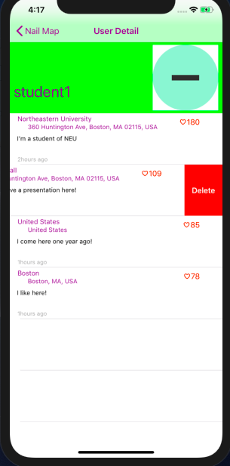
5. 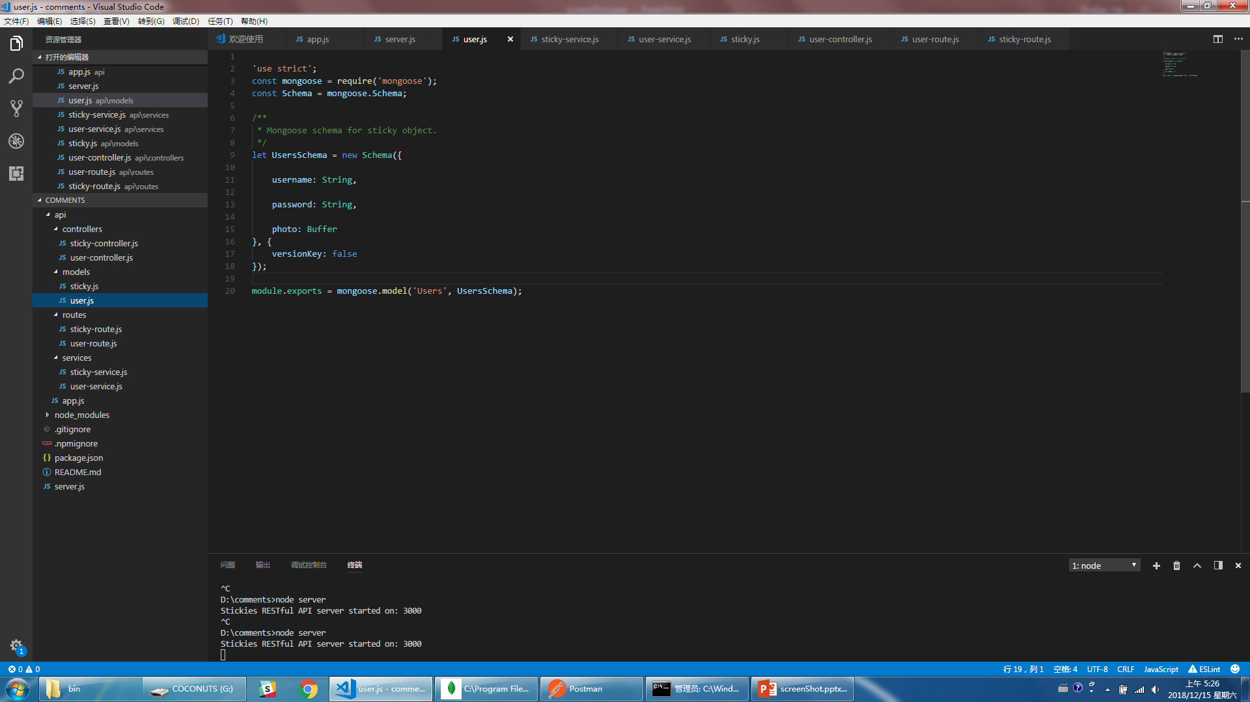**Server build  
   a.** MongoBD as server database  
   **b.** Structure of server: model -> service -> controller -> router  
   **c.** Model is same as entities in swift  
    **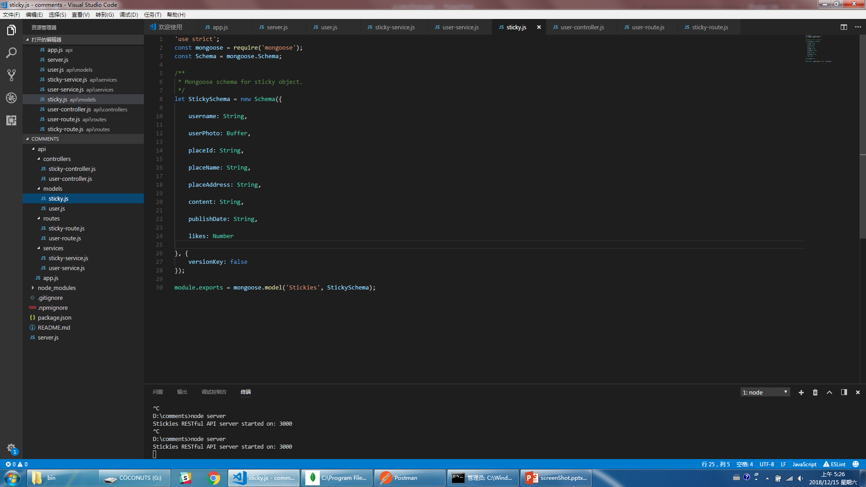  
     
     
     
     
     
     
   d.** Service creates functions for MongoDB   
   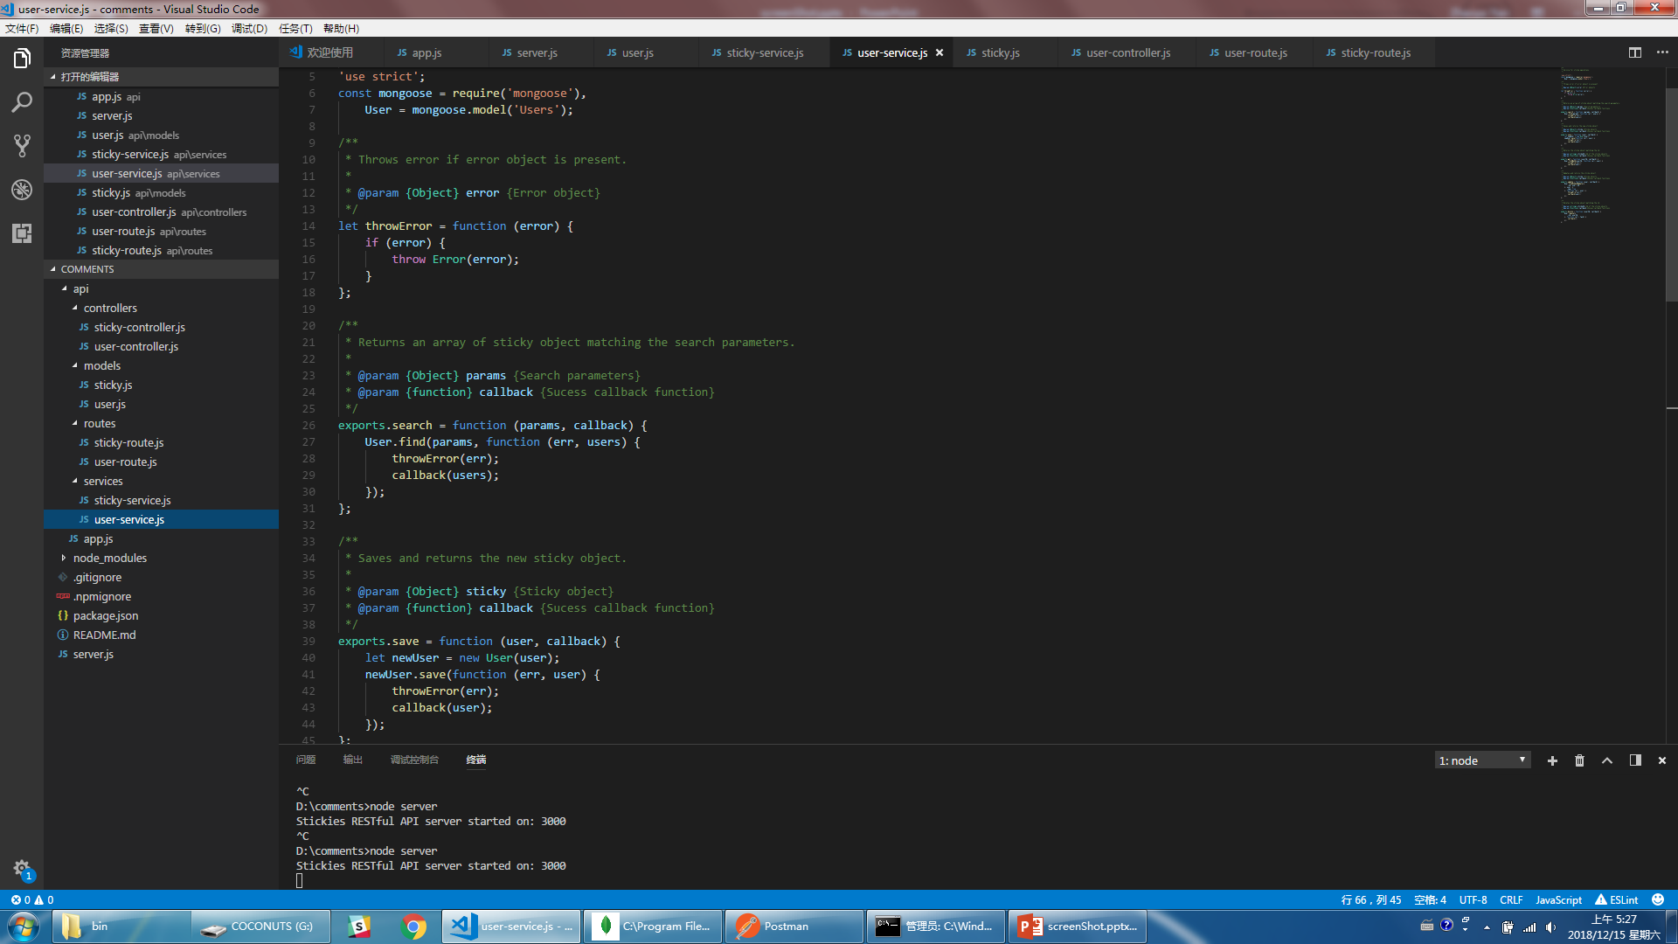  
   **e.** Controller creates methods for web protocol  
   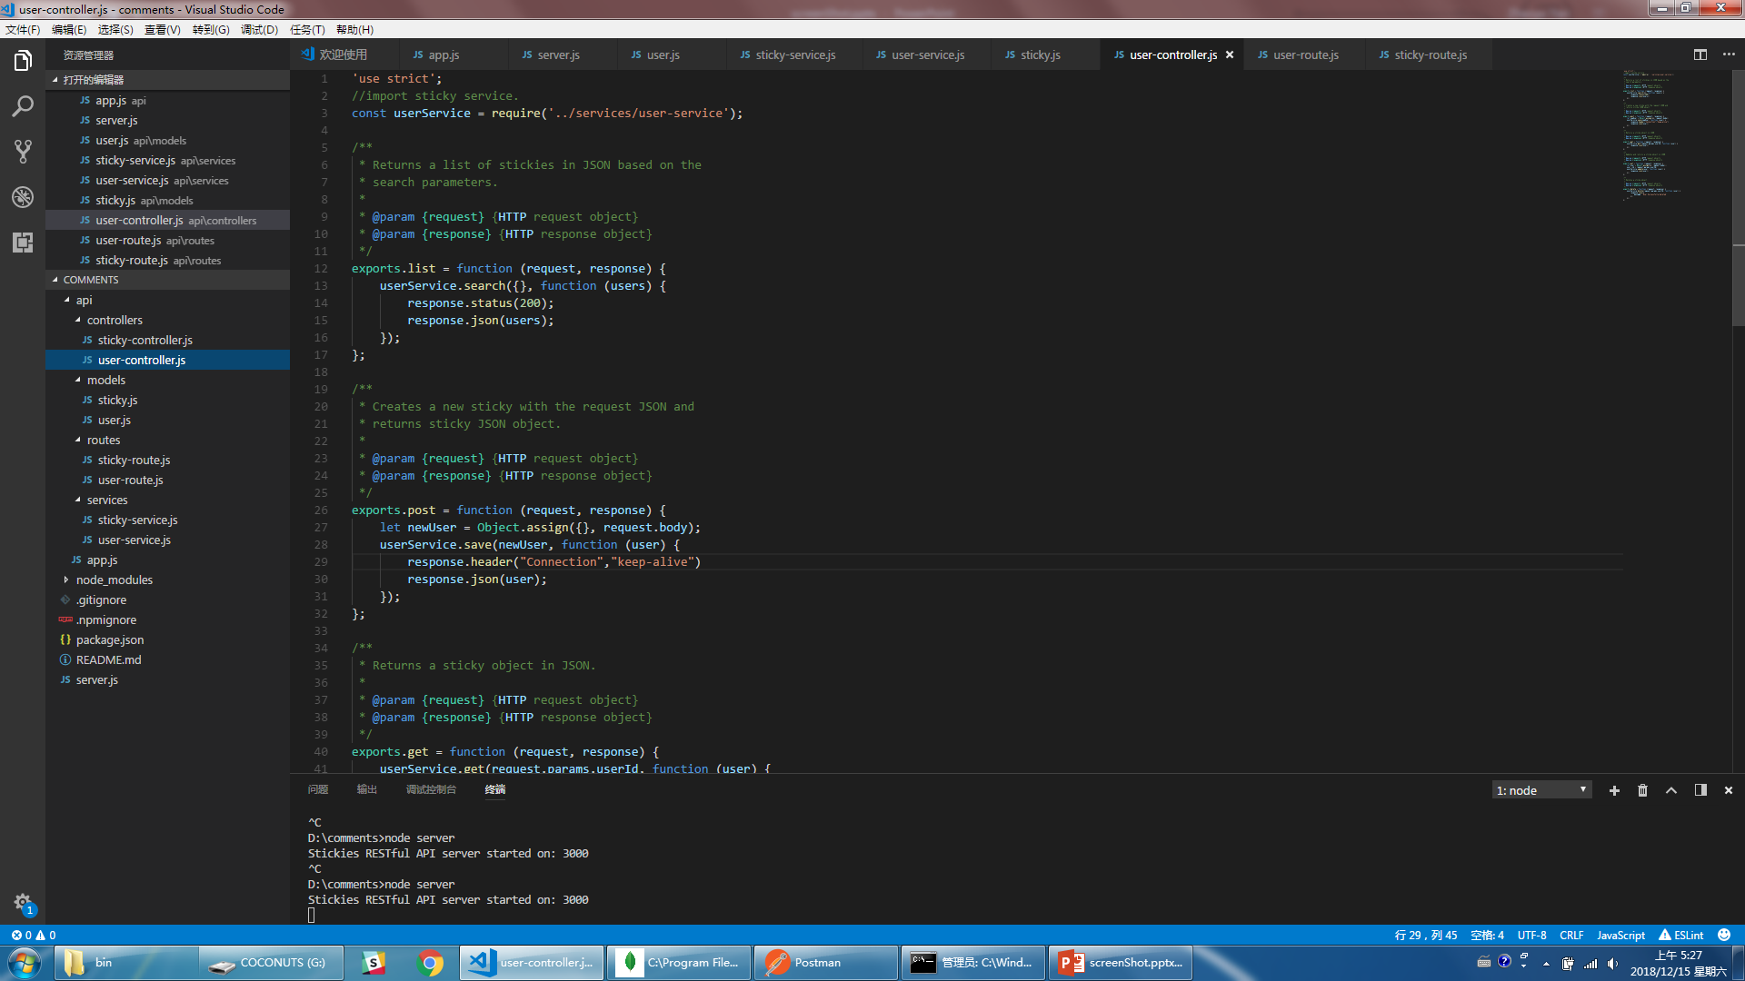  
   **f.** Router sets urls  
   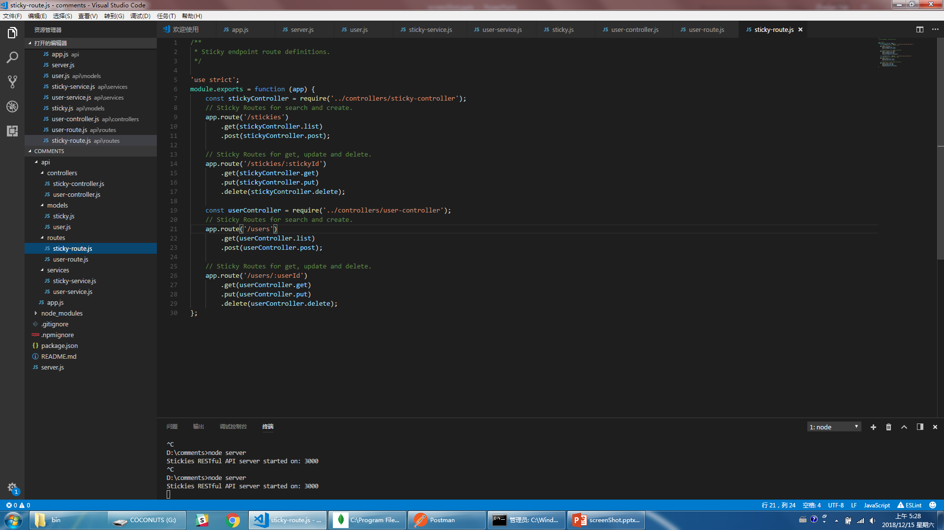  
   **g.** Set port forwarding of my wifi router to public my server port  
   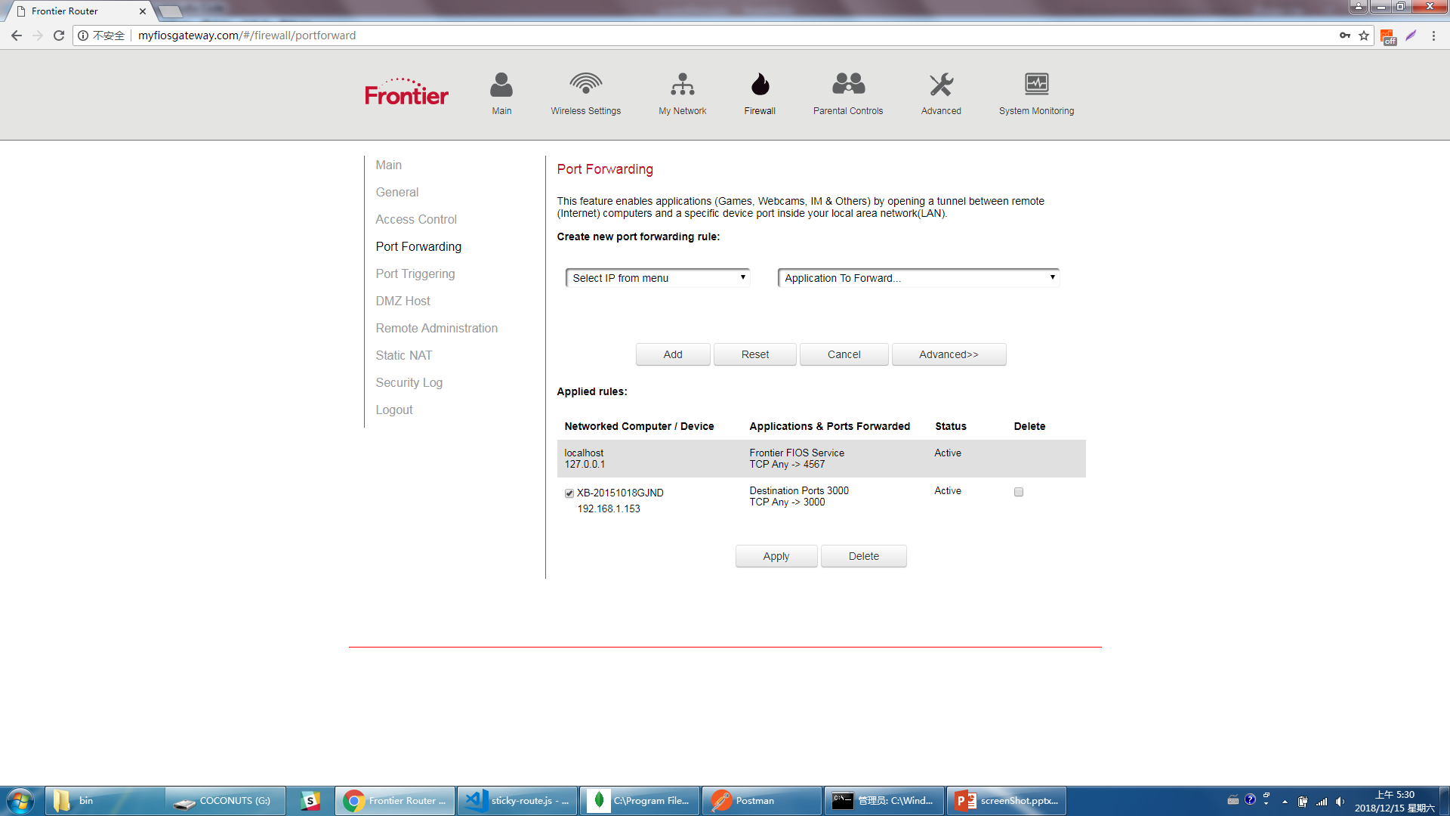  
   **h.** Access to server by url: <http://24.62.61.206:3000/users> & <http://24.62.61.206:3000/stickies>   
     
   